Welcome to Riverside family practice newsletter
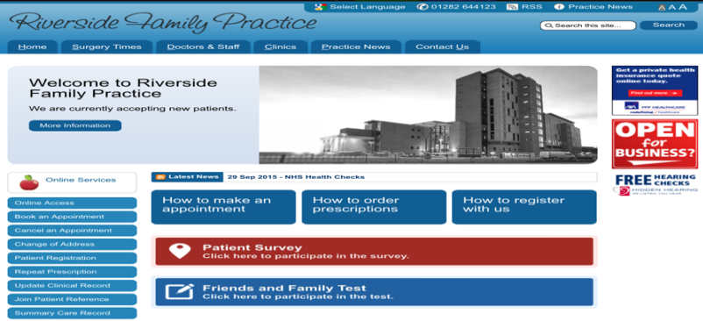
We hope to produce this newsletter once a quarter of a year, and our aim is to provide helpful information about our services and healthcare information.
Saturday morning clinics
We have now been running successfully our Saturday morning morning clinics for the last six months. It has been extremely popular among our patients. If you are unable to make appointments during weekdays please use our Saturday morning clinics.

Chronic disease clinic
Our senior nurse, Allyson Maxwell, is running the chronic disease clinic side-by-side with the flu clinic. If you have; COPD, Asthma, Diabetes, High blood pressure, please ensure you have an annual blood check and a medication review.

Online appointment and prescription request service
We now have a surgery website:
www.riversidefamilypractice.org.uk
You can now make online appointments by submitting a form on our website. You will soon have personal access for online appointments as well as request medications. Please ask our reception for further details.

Text service
Please make sure your contact details are correct and if any of your details have changed please let our reception know as soon as possible. Let us know if you wish to be reminded about your appointment by text message.

NHS health check
The NHS has introduced new health checks to assess the risk of patients developing heart disease, stroke and kidney disease. This service is for all patients registered with the practice who are between the ages of 40 to 74 and do not already have an annual or six monthly checks. Please consult our nurses or doctors for these checks.
Flu vaccination
Our flu clinics are up and running by our nurses, please contact our reception if you are required to have your flu jab.

Patient Participation Group.
We would like to take opportunity to thank all our members for participation in our PPG (Patient Participation Group) meeting. It has give the Riverside team an insight into our patient’s perspective, these meetings will continues on a quarterly base.
- We welcome any feedback regarding our newsletter and our services.
- Please fill out the friends and family test on our website.
- We are also actively taking new patients.
Thank you

,

